**LED Letters Mounting Instructions**

The 6” metal bar has holes to mount to the wall. Use ¼” plastic wall anchors to mount the bar at the right height, and then put the letter over the bar and the magnets will lock it in place. Once you find the slot in the letter you may have to give it a whack to make it seat tightly to the bar.

You can paint the letter if you want, but don’t get paint in the hole on the front. There is a sensor behind the hole that works with the remote.

**Programming the Remote**

You have to program the remote when you first insert or replace the batteries.

Your ONN universal remote control is designed to control up to 4 different audio/video devices such

as TV, DVD, VCR, satellite, cable and audio using only one remote. To use this remote, you will need to program it to control the devices of your choice.

1. The LED letters are programmed to work like a SONY TV. Code is 5321.

2. Press and hold the **SETUP** button until the red indicator light stays on (approximately 2 seconds) and then release the **SETUP** button.

3. Press and release the TV botton on the remote. The red indicator will blink once and then remain on.

5. Enter the first 4-digit code 5321 using the number buttons on the remote. If the code entered is a valid code, the red indicator light will turn off. If the code entered is not a valid code, the

red indicator light will flash and remain on allowing you to re-enter the code**( 5321 for Sony TV)**

**LED Letters Operating Instructions**

The LED letters J and C (to come later) are controlled by a universal remote as shown below.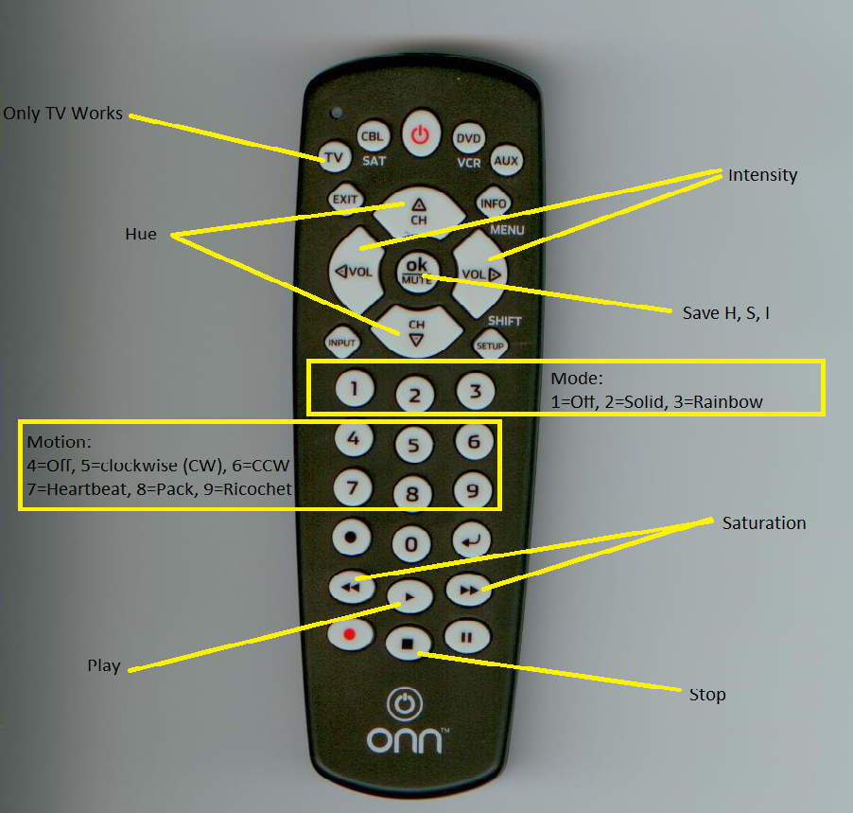

The remote is from Walmart, and is set up to work with a Sony TV. The remote transmits infrared pulses to the letters, and there is a small hole in the front of the letter where the IR receiver is located.

* The “**TV” button** is the only key that works on the remote’s top row. Pressing any other key will make the remote not work, so always press the “TV” button to start things off correctly.
* The letters have 80 LEDs that can be set to any color. The color is a mixture of red, blue, and green and the color is referred to as the **Hue**. The channel up and down buttons change the hue to any of the possible values.
* The **Intensity** refers to how bright any LED is and the volume **“up/down” buttons** control the intensity.
* The **Saturation** refers to how much color vs. white each LED shows and can vary from a bright color to white which is zero saturation. The **“<<” button** decreases the saturation and the **“>> button”** increases the saturation. For example, you can go from bright red to pastel red to white by decreasing the saturation.
* The **“OK|mute”** button saves the current Hue, Saturation, and Intensity values to memory and the display will start at this value the next time power is applied.
* The display has 3 **modes**. The “**1” button** selects an **off mode** and none of the LEDs will be lit. The “**2” button** (solid) sets all the LEDs to the same Hue, Saturation, and Intensity (HSI) value. **The “3” button** selects a rainbowmode where the letters LEDs are distributed across all possible Hues.
* The motion buttons make the LEDs change over time. The “**4” button** selects no motion. The “**5” button** selects clockwise motion, the “**6” button** selects counterclockwise motion. The “**7” button** makes the intensity vary over time in a pulsating way. The “**8” button** makes a group of LEDs chase around the letter. The **“9” button** works like the “8” button but reverses direction at the end of the led string. The **“0” button** works with mode 2 by making the display gradually cycle through all the colors, or with mode 3 by setting each pixel to a random color.
* When the display is moving, all the microprocessor’s processing power is used to run the display. You have to press the “**Stop” button** to make the other keys work once a motion key has been selected.
* The **“Play” button** plays the last selected mode and motion on the display until the “Stop” button is pressed.

When the letters are plugged in, they will automatically resume the last mode and motion that was saved. You can stop the motion with the Stop button and then select any Mode and Motion you want.

A typical session might be:

1. Plug in display
2. Press Stop. You might have to press it several times.
3. Press 2. The display should display a solid color.
4. Press CH+ and CH- to change the color displayed. Vol + and Vol – change the intensity. << and >> adjust the intensity.
5. Press 8 to see a pack of lights circle the letter.
6. Press Stop
7. Press 3 (rainbow)
8. Press 5. The colors should rotate around the letter.
9. Press Stop.
10. Select Solid Mode “2”
11. Select Heartbeat Motion “7”. The display should display a single color that varies in Intensity.
12. Press Stop
13. Press 2. The display should display a solid color.
14. Press 8 to see a pack of lights circle the letter.
15. Press Stop
16. Press 3 (rainbow)
17. Press 5. The colors should rotate around the letter.